Task A: Correlation
Pre-processing:
Null values were handled by ignoring them (NaN) when computing averages.
Mean population (2001–2021) was calculated for each country.
Per capita GDP was computed yearly as:
Per Capita GDP= GDP/Population​
Then the mean per capita GDP (2001–2021) was calculated.

Correlation Analysis:
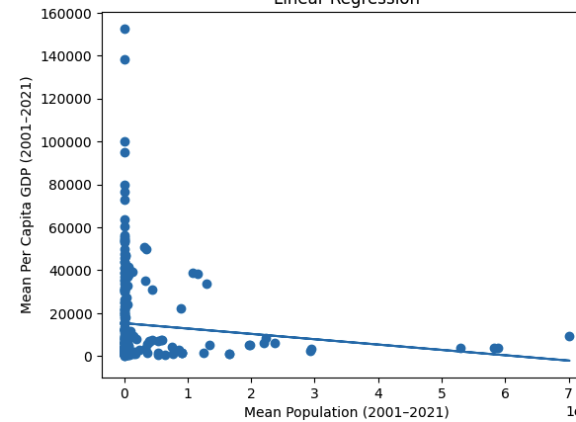
A scatter plot was generated (shown above).
The Pearson Correlation Coefficient is:
(p-value ~ 0.111)
The correlation is very weak and slightly negative( r=−0.09976)

Conclusion:
- Countries with larger populations do not necessarily have higher or lower per capita GDP.
- There is no strong linear relationship between population size and wealth per person.
- The scatter plot confirms this:
Data points are widely dispersed.
A few small-population countries have very high GDP per capita (outliers).
Large-population countries tend to cluster at lower GDP per capita levels.

Task B: Regression
Linear Regression Model
Independent variable: Mean Population
Dependent variable: Mean Per Capita GDP
The regression equation is:

y = -2.489752e-06 * x + 15297.63

Interpretation
The slope is negative but extremely small, meaning:
As population increases, per capita GDP slightly decreases, but the effect is negligible.
The regression line is almost flat, confirming population size is not a strong predictor of per capita GDP.
Combined with the weak correlation, the model has low explanatory power.
Overall Conclusion
There is no meaningful linear relationship between a country’s population size and its per capita GDP.
Economic prosperity per person depends on many other factors (e.g., productivity, institutions, resources), not just population.

